Required Coding Activity 11.3: Customizing Bootstrap Code

Step 1: First, download the zip file Activity 11.3 Links to an external site. Take a screenshot to demonstrate that you successfully downloaded the file and opened it in VS Code.
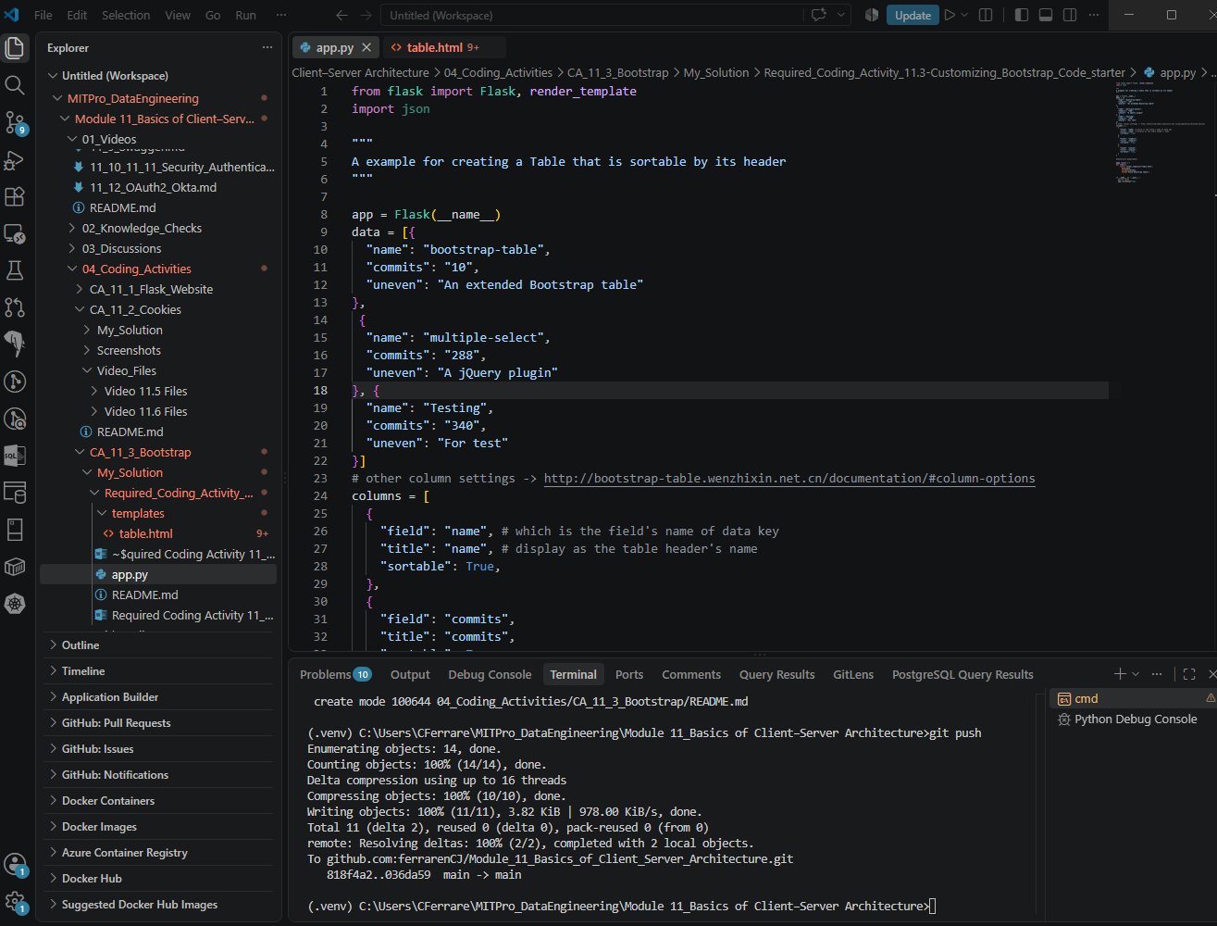

Step 2: Open the app.py file. Take a screenshot to demonstrate that you completed this step successfully.

Step 3: By carefully inspecting the app.py file, you will see that entries for a table with three rows and three columns have been defined, as well as the entries in the table.

Step 4: Run and debug your code. Navigate to localhost/5000 and provide a screenshot of the table defined in the app.py file.

Step 5: Go back to the app.py file and edit the entries in your table as you wish. In other words, the entries in the table can be about anything that interests you or about material already learned in the course. Keep the dimensions of the table to three rows and three columns. Provide screenshots of your edited code in the app.py file. Note that for this step you will likely need to provide multiple screenshots, as all the edited code might not fit in one screenshot.

Step 6: Run and debug your code. Navigate to localhost/5000 and provide a screenshot of your updated table defined in app.py.

